**Interposer Background Information and CapSense Theory**

Version 0.5.3 December 21, 2018

Interposer Physical Reference & Terminology 1

Overview 1

Interposer PCB 1

Interposer Module Assembly 1

Sensor Grouping FW Configuration 1

Sensor Material and Dimensions 2

CapSense Basic Theory and Parameters 2

Sense Clock Frequency Calculation 3

Interposer Manufacturing FW Interface 3

Boot manufacturing firmware from bootloader (Slides by jennifersilva@) 3

Command list of Mfg Firmware (from Alicia Skilton at FIT) 4

**Appendix A - Manufacturing firmware commands** **5**

CAD Matrix 9

Version Control 9

### 

### 

### 

### 

### 

### 

### 

### 

### Interposer Physical Reference & Terminology

#### Overview

The Interposer is an electronic module embedded in the garment of a Jacquard-enabled product. Its main capability is capacitive sensing of hand gestures performed on the garment surface and this will be the main focus of this document.

#### Interposer PCB

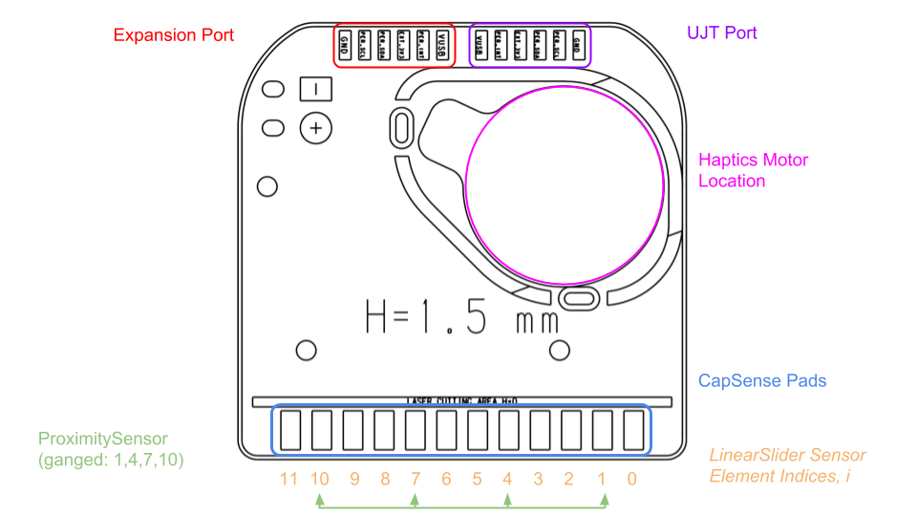

As seen in the diagram above, there are 12 available pads for capacitive sensing on the Interposer onto which sensors will be soldered.

#### Interposer Module Assembly

#### Sensor Grouping FW Configuration

In the current Interposer firmware sensor configuration, there are 2 sets of “Sensor Widgets” that are multiplexed onto these pads. The first is the LinearSlider, which is a sensor array composed of 12 individual sensor elements, one on each pad, with indices starting from 0 and up to 11. Each sensor element will produce a digital reading upon a full LinearSlider scan. This is the main sensor widget used to actually detect hand gestures with a near field response. The other sensor widget is the ProximitySensor which is a single sensor composed of multiple sensor pads ganged into one element. Upon a ProximitySensor scan, it will produce a single digital reading, with a far field response.

在当前Interposer固件传感器配置中，有两组“传感器部件”被多路复用到这些pad上。第一个是LinearSlider，它是由12个独立的传感器元素组成的传感器阵列，每个pad上有一个，索引从0到11。每个传感器元件将产生一个全线性滑块扫描数字读数。这是主要的传感器部件，用于实际检测带有近场响应的手势。另一个传感器部件是ProximitySensor，它是由多个传感器板组合成一个元素的单个传感器。在近距离传感器扫描时，它将产生一个具有远场响应的数字读数

#### Sensor Material and Dimensions

|  |  |
| --- | --- |
| **Sensor Config** | **Touch Area Sensor Pitch** |
| KML | 5mm |
| KMY-Ribbon | 10mm |

### CapSense Basic Theory and Parameters

For detailed theory on Self-Capacitive Sensing Method refer to Page 2 to Page 16 [this document](https://drive.google.com/open?id=1eB9VE7Nio8YuZsjCNzAEHo0zLtY39-Zk) from Cypress. This is important to understand to implement a thorough CapSense manufacturing test.

**Equation 1. Analog (capacitance) to Digital (raw count):**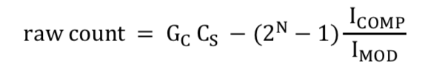

|  |  |
| --- | --- |
| Gc | Gain of the sensor (see equation 2) |
| Cs | Capacitance, measured in Farads |
| N | Scanning Resolution |
| Icomp | Compensation IDAC, in Amps (2.4 uA/LSB) |
| Imod | Modulation IDAC, in Amps (2.4 uA/LSB) |

**Equation 2. Gain**

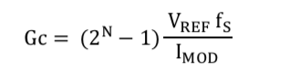

|  |  |
| --- | --- |
| VREF | Fixed constant for 4100S series chip: 2.0211V |
| fs | Sense Clock Frequency |
| IMOD | Modulation IDAC: 2.4 uA/LSB |
| N | Scanning Resolution |

#### Sense Clock Frequency Calculation

Sense Clock Frequency = Modulation Clock Frequency/**Sense Clock Frequency Divider**

Modulation Clock Frequency = **HFCLK**/**Modulation Clock Frequency Divider**

**Bolded variables are provided by the Mfg FW’s “i” command.**

With the above two equations, any raw count reading can be calculated into a physical capacitance value.

The rationale behind converting raw count back into capacitance to be used as the unit of reference for test criteria is that the numerical range for raw count produced upon touch can vary dramatically depending on the gain of the sensor, whereas capacitance is representative of the physical touch and is a lot more stable as a numerical threshold.

利用上述两个方程，任何原始计数读数都可以计算成一个物理电容值。

背后的基本原理将原始计数转化为电容作为参考单元测试标准是原始计数产生的数值范围在触摸可能显著不同取决于传感器的增益,而电容是代表身体接触和更稳定的数值阈值

### Interposer Manufacturing FW Interface

#### Boot manufacturing firmware from bootloader (Slides by jennifersilva@)

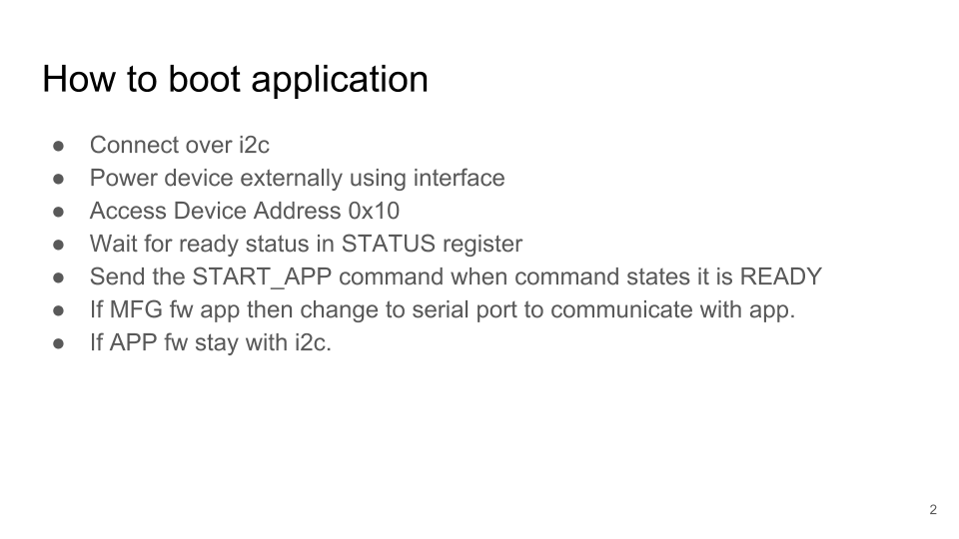

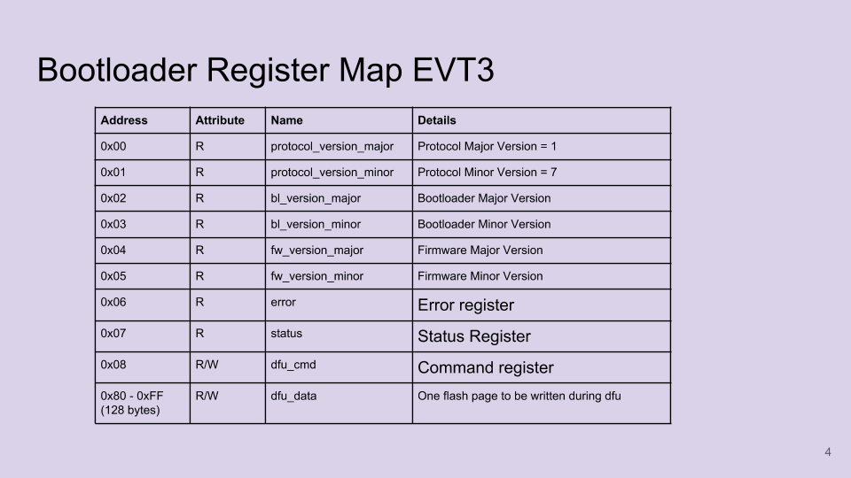

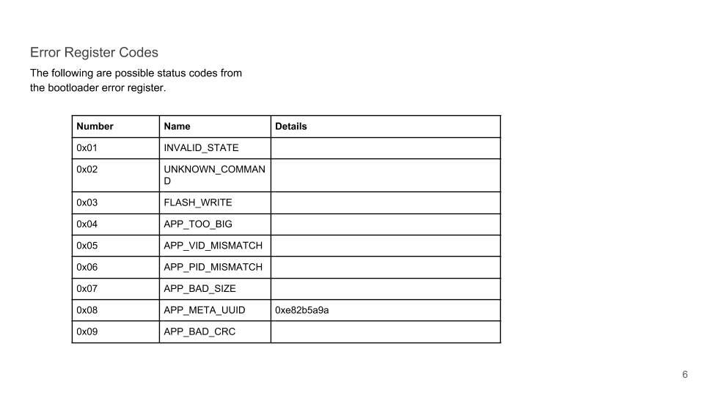

#### Command list of Mfg Firmware (from Alicia Skilton at FIT)

Important Commands for Innorev Highlighted in Red.

# Appendix A - Manufacturing firmware commands

This section summarizes the commands accepted by the manufacturing firmware

|  |  |  |
| --- | --- | --- |
| **Command** | **Description** | **Example output** |
| h | Help. Report list of commands. | Command: help\r\n  i - Report info\r\n  c - Test capacitance on pins TOUCH_1 - 12\r\n  ... |
| i | Info: Report firmware version and stored serial number | Command: Info\r\n  Factory config:\r\n  Manufacturing ID: GKPFKE38C170000\r\n  Google ID: 1-05-GKPFKE38C170000-914S\r\n  Gear ID: 0123456789\r\n  Vendor ID: 0\r\n  Product ID: 0\r\n  Hardware revision: 5\r\n  HFCLK Frequency: 48000kHz\r\n  Cap-sense config:\r\n  CSD tuning mode: 0\r\n  Scan Resolution: 13\r\n  Sense Clock Frequency (divider): 8\r\n  Modulation Clock Frequency (divider): 1\r\n  Modulation IDAC Value: 10\r\n  Noise Threshold: 37\r\n  Compensation IDAC Values:  Prox L0 L1 L2...\r\n  7, 7, 9, 7,...\r\n |
| c | Continuously report capacitance on Prox and TOUCH0-11 until <Enter> key pressed. 在Prox和TOUCH0-11上连续报告电容，直到按下<Enter>键 | Command: Parasitic capacitance values in pF\r\n寄生电容值(PF)  Press any key to stop\r\n  P L0 L1...\r\n  CSD: 0, 10, 11,...\r\n  CSD: 0, 10, 11,...\r\n  ... |
| r | Continuously report raw cap-sense values on Prox. and TOUCH0-11 until <Enter> key pressed. 在Prox上连续返回原始cap值 和TOUCH0-11,直到<Enter>键被按下。 | Command: Raw touch values\r\n  Press any key to stop\r\n  Prox L0 L1...\r\n  49294,13027,11530,...\r\n  49579,13025,11523,...\r\n  ... |
| t | Continuously report differential cap-sense values on Prox. and TOUCH0-11 until <Enter> key pressed. 持续报告相邻两条上的电容差值和TOUCH0-11直到<Enter>键被按下 | Command: touch values\r\n  Press any key to stop\r\n  Prox L0 L1...\r\n  0, 0, 0,...\r\n  127, 0, 0,...\r\n  ... |
| a | Continuously report all cap-sense values on Prox. and TOUCH0-11 until <Enter> key pressed. 在Prox上连续报告所有cap值和TOUCH0-11直到<Enter>键被按下 | Command: touch values\r\n  Press any key to stop\r\n  Prox L0 L1...\r\n  d: 0, 0, 0,...\r\n  r:49413,13045,11536,...\r\n  b:49338,13026,11526,...\r\n  i: 4, 4, 5,...\r\n  c: 0, 10, 11,...\r\n  ... |
| S | Run cap-sense self-test | Command: Run capsense self-test\r\n  SUCCESS\r\n  Capacitance values (in pF):\r\n  P L0 L1 L2…\r\n  CSD: 36, 10, 11, 11,....\r\n  Vdda=3.302V\r\n |
| p | Tests that pins are not shorted together: 测试引脚没有短路在一起   * Configure TOUCH_INT, TOUCH_1 - TOUCH_10 with internal pull-down. * Verify the state is logic 0. * For i in TOUCH_INT, TOUCH1-TOUCH10:   + Configure pin i to output high   + Read state of all other pins. Verify state is logic 0. | Command: Short circuit test\r\n  Testing for ground shorts…\r\n  Testing for shorts to VCC…\r\n  Testing for shorts between signal pins…\r\n  SUCCESS\r\n  Or  Error: TOUCH_12 stuck low.\r\n  Or  Error: TOUCH_12 stuck high.\r\n |
| q | Test short on pins EXP_INT, EXP_SCL, and EXP_SDA在引脚EXP_INT，EXP_SCL和EXP_SDA上测试短路 | > Command: EXP Short circuit test\r\n  Testing for ground shorts...\r\n  Testing for shorts to VCC...\r\n  Testing for shorts between signal pins...\r\n  SUCCESS\r\n  Or  Error: EXP_0 stuck high.\r\n |
| g | Test that pins are connected to MCU. 测试引脚是否连接到MCU   * Configures each pin TOUCH_INT, TOUCH_1 - TOUCH_10 with internal pull-down●通过内部下拉配置每个引脚TOUCH_INT，TOUCH_1 - TOUCH_10 * Verify the state is logic 1 for each pin. 验证每个引脚的状态是否为逻辑1 | SUCCESS\r\n  Or  Error: TOUCH_6\r\n (Indicating that pin TOUCH_6 was not observed high) TOUCH_6 \ r \ n（表示没有观察到引脚TOUCH_6为高电平） |
| n | Read digital input level on peripheral connector pin读取外围连接器引脚上的数字输入电平 | Command: Read peripheral connector pin\r\n  t - TOUCH_INT\r\n  e - EXP_INT\r\n  c - EXP_SCL\r\n  d - EXP_SDA\r\n  any other character - exit\r\n  ‘t’: TOUCH_INT: High\r\n  ‘e’: EXP_INT: Low\r\n  ‘c’: EXP_SCL: Low\r\n |
| e | EEPROM: Write Gear ID, Vendor ID, or Product ID EEPROM：写入gear ID，供应商ID或产品ID | Command: Write ID to Mfg Data section  Select ID to write\r\n  g - Write Gear ID\r\n  v - Write Vendor ID\r\n  p - Write Product ID\r\n  any other character - exit\r\n  ‘g’: Enter Gear ID:\r\n  Example input: 0123456789\r\n  “SUCCESS\r\n” or “Invalid ID\r\n” |
| W | EEPROM: Write Gear sector | enter gear data:\r\n  “SUCESS\r\n” or  “Error: Write failed error=<error code>” |
| R | EEPROM: Read Gear sector | Command: Read Gear sector\r\n  00 00 00 00 …\r\n |
| d | Deep Sleep Enters Deep Sleep mode. Must remove and then apply power to exit sleep mode.   Note that power can sync off the tx and rx lines of the uart, so you must disconnect everything. | Entering Deep Sleep\r\n  Must Power Cycle to wake\r\n |
| s | NOT IMPLEMENTED YET Sleep Enters Sleep mode. Must remove and then apply power to exit sleep mode. | Entering Sleep Mode\r\n  Must Power Cycle to wake\r\n |
| V | Enable Haptics | Enabling haptics\r\n  Haptics enabled\r\n |
| v | Disable Haptics | Disabling haptics\r\n  Haptics disabled\r\n |
| l | LED control | Command: LED Control\r\n  Enter RGB values:\r\n  Example input: 010203\r\n  Initializing I2C...\r\n  Initializing LED Driver...\r\n  SUCCESS\r\n  Or  I2C Error: error code=8\r\n |
| x | Perform system reset | Resetting\r\n |
| <Other> | Behavior for unknown command | Error: Unknown command\r\n |

### CAD Matrix

|  |  |  |  |  |  |  |  |  |  |
| --- | --- | --- | --- | --- | --- | --- | --- | --- | --- |
| **Item** | **KML** | | | **KMY** | | | **KMS** | | |
|  | Interposer OQC/IQC | IPQC (cuff) | OQC (garment) | Interposer OQC/IQC | IPQC (strap) | OQC (backpack) | Interposer OQC/IQC | IPQC (strap) | OQC (backpack) |
| 2D |  |  |  |  |  |  |  |  |  |
| 3D | [.stp](https://drive.google.com/open?id=1aSO6Rl0b3I3bGywE0oIDN5V0Rj4w1Upq) |  |  | [.stp](https://drive.google.com/open?id=1Z7_PzzeA5cPorgSXoM0ARWp8xHzH2IhP) |  |  | [.stp](https://drive.google.com/open?id=1KA7W2cqn19phc_r7bh3-SAvtkODTl_wH) |  |  |

### Version Control

|  |  |  |  |
| --- | --- | --- | --- |
| **Version** | **Date** | **Author** | **Remarks** |
| 0.5.3 | 2018.12.21 | wtony@ | Updated Mfg FW commands |
| 0.5.2 | 2018.12.10 | wtony@ | Add bootloader information |
| 0.5.1 | 2018.11.12 | wtony@ | Updated Interposer PCB image |
| 0.5 | 2018.10.4 | wtony@ | Draft pending review |
|  |  |  |  |